EXPT NO:4 | Visual encoding of data
DATE: 20.01.2026

PRE-LAB QUESTIONS

How does the human visual system process visual variables?

Humans detect visual features quickly (pre-attentively) like color, size, position, and shape before thinking.
So we understand patterns fastest when data is shown using clear visual cues.

Why is improper encoding misleading in analytics?
Wrong encoding can hide truth or exaggerate results.
Example: using similar colors for different severities may look “same”, causing wrong decisions.

What are perceptual limitations in visualization?
Common limitations are:
  - Hard to compare angles/areas accurately (pie charts, bubbles)
  - Too many colors confuse users
  - Small differences in shades may not be noticed
  - Overloaded charts reduce clarity

How does color choice affect interpretation?

Color strongly changes meaning:

Red = danger / high severity
  - Green = safe / low severity
Bad color selection can cause confusion, especially for color-blind users or if contrast is low.

Why should AI dashboards be perceptually optimized?

Because AI dashboards are used for fast decision-making. If visuals are not clear:
  - users may misread predictions
  - high-risk areas may be ignored
  - wrong actions may be taken
So dashboards must be simple, readable, and accurate visually.

OBJECTIVE: To apply effective visual encoding principles for meaningful data communication. SCENARIO: A city traffic department analyzes accident data to identify high-risk zones and accident severity patterns.
IN-LAB TASKS (Using R Language) • Encode severity using color gradients • Represent accident frequency using size • Use shape to indicate accident type

CODE:
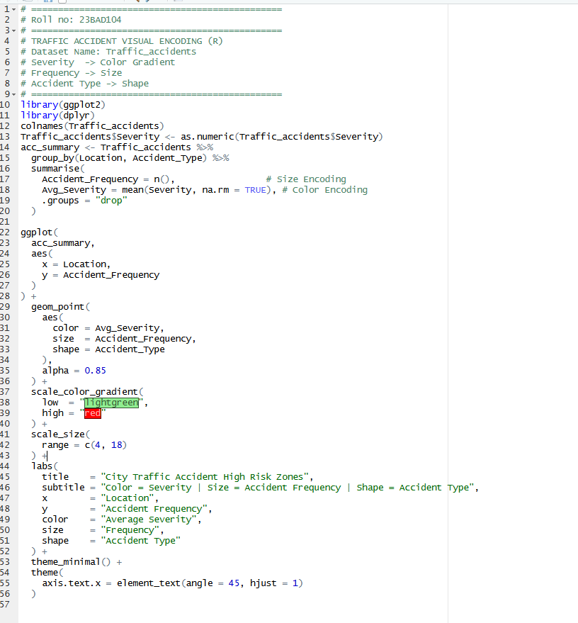

OUTPUT:
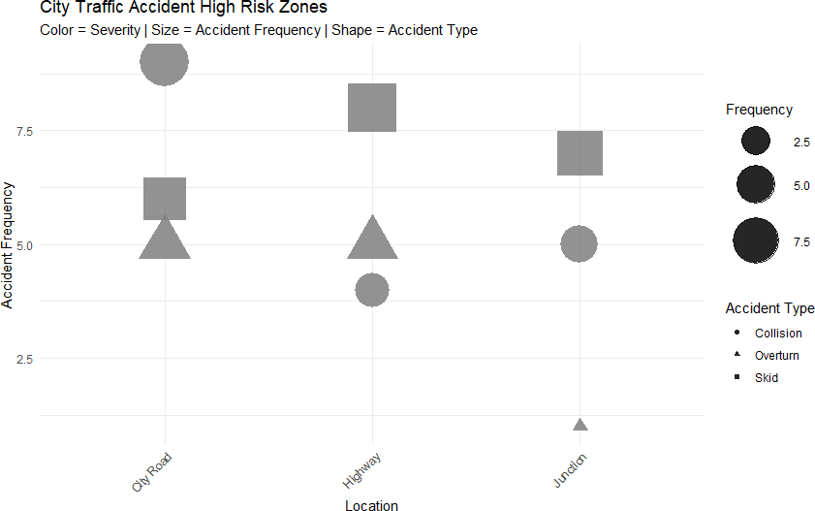

POST-LAB QUESTIONS

Which visual variable best conveys severity and why?
Color gradient is best for severity because it instantly shows intensity levels (low → high)
and is easy to compare across zones.

How can poor encoding mislead policy decisions?
Poor encoding can show wrong high-risk areas, so officials may:
  - place traffic signals in wrong zones
  - ignore real accident hotspots
  - waste budget and manpower
This leads to incorrect safety policies.

What precautions should be taken for color-blind users?
  - Use color-blind friendly palettes (avoid only red–green)
  - Add labels/legends
  - Use shape + size along with color (not color alone)
  - Ensure high contrast between levels

How does visual encoding affect AI explainability?
Good encoding makes AI results easy to understand and trust.
Example: If severity is clearly shown using colors, users can quickly relate AI predictions to real-world risk, improving explainability.

Suggest improvements for large-scale public dashboards.
  - Add filters (location, date, severity, accident type)
  - Use interactive maps with zoom
  - Show top hotspots list

LEARNING OUTCOME: Students learn perceptually effective visual communication for AI systems.

ASSESSMENT

Description | Max Marks | Marks Awarded
Pre Lab Exercise | 5
In Lab Exercise | 10
Post Lab Exercise | 5
Viva | 10
Total | 30
Faculty Signature

